Supplementary material

Process engineering strategy for improved methanol production in Methylosinus trichosporium through enhanced mass transfer and solubility of methane and carbon dioxide
Krishna Kalyani Sahooª, Ankan Sinhaª and Debasish Das^{a,} *

ªDepartment of Biosciences & Bioengineering, Indian Institute of Technology, Guwahati, Assam 781039, India

*Corresponding author:
Professor,
Department of Biosciences & Bioengineering,
Indian Institute of Technology Guwahati,
Guwahati, Assam 781039, India.
Tel.: +91-361 258 2221; fax: +91-361 258 2249.
E-mail addresses: debasishd@iitg.ac.in (D. Das).

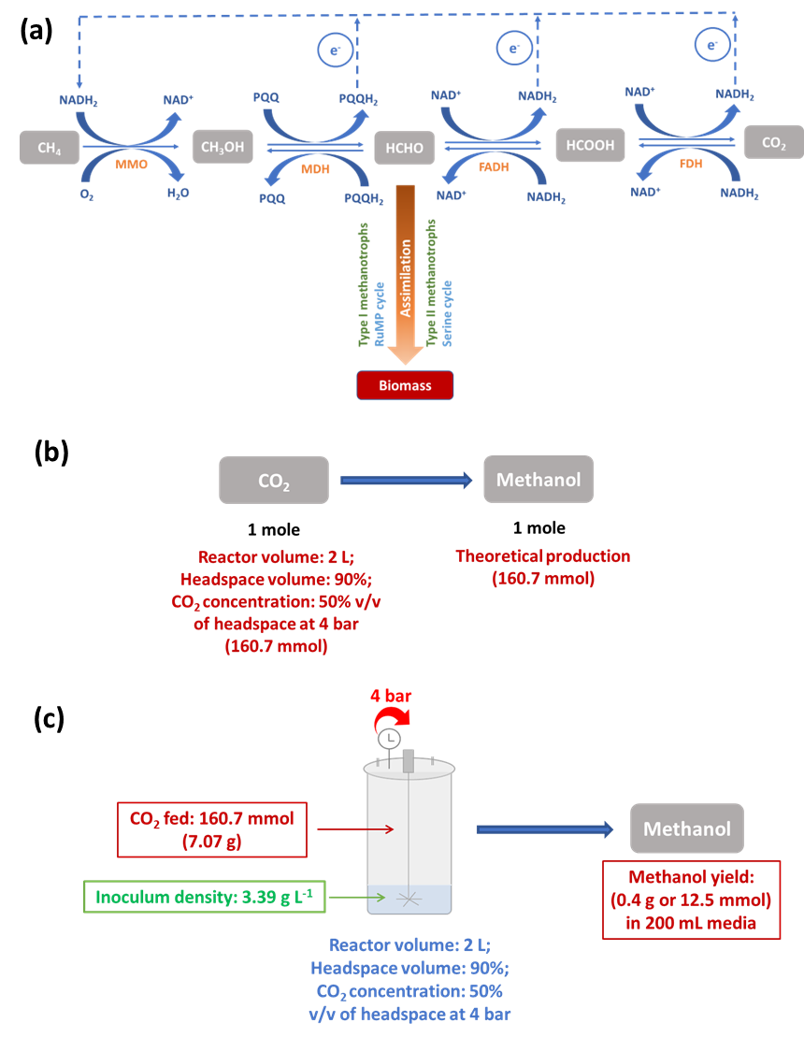

Fig. A.1. (a) Metabolic pathway in methanotrophs for methanol production through oxidation of methane or reduction of CO₂. Methanol is produced from methane oxidation by inhibiting the activity of enzyme MDH to prevent further oxidation of methanol. MMO: methane monooxygenase, MDH: methanol dehydrogenase, FADH: formaldehyde dehydrogenase, FDH: formate dehydrogenase, NADH: nicotinamide adenine dinucleotide hydrogen, PQQ: pyrroloquinoline quinone, and RuMP: ribulose monophosphate; (b) Stoichiometric equation to produce methanol from CO₂; and (c) Methanol production from CO₂ under experimental conditions.
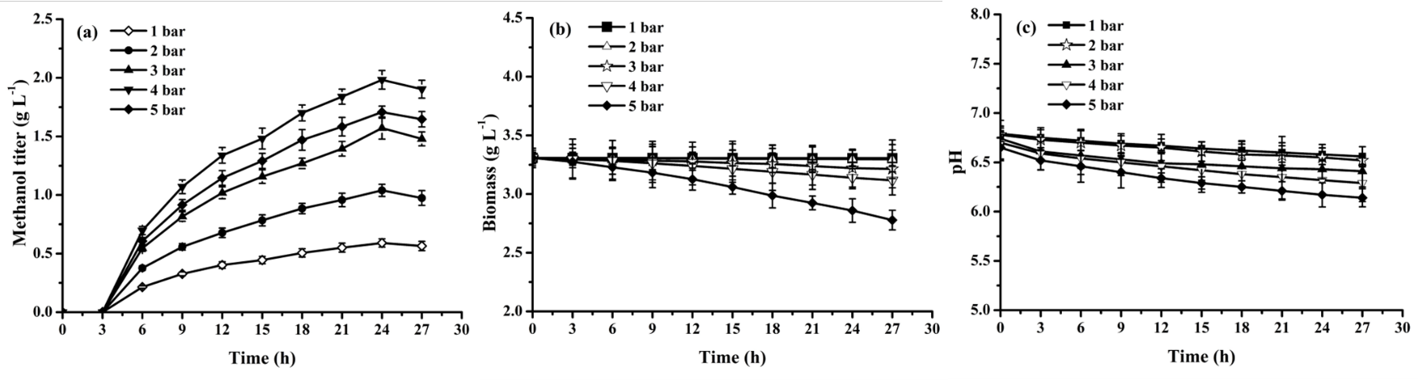
Fig. A.2. Dynamic profile for (a) methanol, (b) biomass, and (c) pH under varying operating pressures in high-pressure stirred tank reactor. Significant differences (p ≤ 0.05) were noted through statistical analysis using one-way ANOVA.

Table A.1. Comparison of methanol production by methanotrophs under different process conditions and reactor types.
Methanotroph | Substrate | Process/Reactor specifications | Methanol/Biomass titer/yield | References
Methylosinus  trichosporium IMV 3011 | CO₂: air  (50:40) | Batch culture;  100 mL conical flask | 0.004 μmol/mg dry cell weight | Xin et al., 2007
Methylosinus sporium | CO₂-air (30:70) | Batch culture;  120 mL serum bottle | 0.33 mM | Patel et al., 2016
Methylocystis bryophila DSM 21852 | CO₂: air (15:85) | Covalent immobilization of cells on chitosan;  Repeated-batch culture (5 cycles); 120 mL serum bottle | 0.52 mM  (0.017 g L⁻¹) | Patel et al., 2018
Methylotuvimicrobium alcaliphilum | Methane: oxygen (1:1) | Fed-batch culture, 14 L fermenter | 0.418 g L⁻¹ | Kulkarni et al., 2021
Methylosinus trichosporium OB3b | Methane: air (1:1) | Batch-mode with continuous feeding of methane-air mixture; Cylindrical reactor with circulation diffusion system (Total volume: 3 L, working volume: 1 L) | 13.7 mM  (0.44 g L⁻¹) | Kim et al., 2010
Methylosinus trichosporium NCIMB 11131 | CO₂: air (1:1) | Batch culture, 250 mL Airtight batch reactor | 0.58 g L⁻¹ | Sahoo et al., 2022
Methylocystis bryophila DSM 21852 | Simulated biogas mixture of Methane: CO₂ (2:1) | Covalent immobilization of cells on chitosan;  Repeated-batch culture (8 cycles); 120 mL serum bottle | 25.75 mM  (0.82 g L⁻¹) | Patel et al., 2018
Methylocella tundrae | Biogas derived from anaerobic digestion of potato peels (30% methane) | Covalent immobilization of cells on banana leaves; Repeated-batch culture (8 cycles); 10 mL serum bottle | 25.86 mM  (0.83 g L⁻¹) | Patel et al., 2021
Methylocaldum sp. 14B | Biogas: air (1:2.5) | Trickle-bed reactor packed with ceramic balls (1.24 L) | 0.9 g L⁻¹ d⁻¹ | Sheets et al., 2017
Methylosinus trichosporium OB3b | Methane: oxygen (1:1) | Batch culture; Bubble-free membrane aerated  bioreactor (Total volume: 500 mL, working volume: 300 mL) | 0.95 g L⁻¹ | Duan et al., 2011
Methanotrophic strains (AS1 and AS2) isolated from activated sludge | Methane: air (50:50) | Batch and sequencing batch mode (5 cycles);  External-loop airlift bioreactor (working volume: 1 L) | 1.6 g L⁻¹ | Ghaz-Jahanian et al., 2018
Methylocystis bryophila | Methane: air (30:70) | Covalent immobilization of cells on coconut coir; Repeated-batch culture (8 cycles); 120 mL serum bottle | 52.9 mM  (1.69 g L⁻¹) | Patel et al., 2020a
Methylosinus trichosporium NCIMB 11131 | CO₂: air  (1:1) | Batch culture;  High-pressure stirred tank reactor (Total volume: 2 L; working volume: 1.2 L); Optimum operating pressure: 4 bar | 61.8 mM  (1.98 g L⁻¹) | This study

